NonLINEAR OBSERVABILITY FOR RELATIVE SATELLITE ORBITs WITH ANGLES-ONLY MEASUREMENTS

T. Alan Lovell, and Taeyoung Lee
Nonlinear observability criteria are developed for relative orbital motion between two spacecraft. Given a circular orbit of a chief spacecraft, it is assumed that the line-of-sight from the chief toward a deputy spacecraft is measured. A differential geometric method, based on Lie derivatives of the measurements, is applied to obtain sufficient conditions for observability of nonlinear relative orbital motion, and observability criteria are analyzed. An extended Kalman filter is also developed to numerically illustrate the observability of nonlinear relative orbits with angles-only measurements.
Introduction
Relative navigation is desirable for many spacecraft missions, such as formation control and rendezvous, since spacecraft maneuvers based only on on-board measurements can reduce the total operating cost significantly, and it improves safety against communication interruptions with ground stations. For these close proximity missions, relative navigation essentially reduces to space-based orbit determination. Vision-based navigation and estimation problems have received attention, since optical sensors have desirable properties of low cost and minimal maintenance, while providing accurate line-of-sight measurements.
Relative navigation based on angles-only measurements has been the subject of much recent investigation (e.g. References 1-3). The problem is to determine the relative orbit between a chief spacecraft and a deputy spacecraft by using the line-of-sight between the two objects, assuming that the orbit of the chief is known. Reference 1 shows that the relative orbit is unobservable from angles-only measurements when linear relative orbital dynamics are assumed, unless there are thrusting maneuvers. Reference 2 investigates observability by using a relative orbit model linearized about spherical coordinates. Reference 3 introduces the concept of partial observability to determine a basis vector representing a family of relative orbits, and an initial orbit determination technique for this method. However, all of these results are based on linear relative orbital dynamics.
In this paper, the authors derive observability criteria for the nonlinear relative orbital dynamics represented by the solutions of the two-body problem. Assuming that a chief is on a circular orbit with a prescribed orbital radius, nonlinear equations of motion for the relative orbital motion of a deputy with respect to the chief are derived. A differential geometric method, based on the Lie derivatives of the line-of-sight from the chief to the deputy⁴, is applied to obtain sufficient conditions for observability. It is shown that under certain geometric conditions on the relative configuration between the chief and the deputy, the nonlinear relative motion is observable from angles-only measurements. We also develop an extended Kalman filter to illustrate the observability properties numerically.
NONLINEAR OBSERVABILITY CRITERIA
Observability criteria for nonlinear relative orbital motion are developed as follows. Let be the relative position of the deputy with respect to the chief. The line-of-sight measurement from the chief toward the deputy is given by the unit-vector 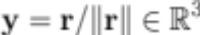. From the second-order Lie derivatives of the measurement, a nonlinear observability matrix is defined as
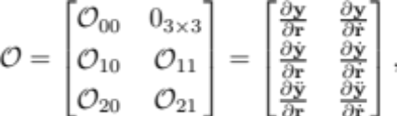
where each sub-matrix is expressed in terms of the relative position , the relative velocity , and the orbital radius of the chief.
According to nonlinear observability theory, the relative orbit motion is observable if the observability matrix has the full rank of six⁴. The resulting observability rank conditions are summarized as follows:
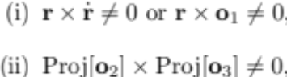
where  denotes the orthogonal projection of a vector to the plane normal to , and the vectors  are defined as
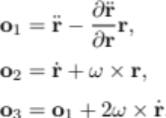
for the orbital angular velocity vector of the chief. In short, the nonlinear relative orbital motion is observable if the above two conditions (i) and (ii) are satisfied.
Several cases are identified where one of these conditions is not satisfied. These include the case when the relative position is parallel to the relative velocity observed in the local-vertical, local-horizontal (LVLH) frame; another case where the relative position is parallel to the relative velocity observed in the inertial frame; and the third case where the relative motion is co-planar with the orbital plane of the chief. But, as the given criteria (i) and (ii) are only sufficient conditions, observability is indeterminate for these three cases. Further analysis based on higher order Lie derivatives of the measurement is required to determine observability when the given criteria are violated.
NONLINEAR Relative Orbit ESTIMATION
To illustrate observability of nonlinear relative orbital maneuvers, we developed an extended Kalman filter based on the line-of-sight measurements. The chief is on a circular orbit with an orbital altitude of 500km, and the initial condition of the deputy is chosen such that the corresponding relative motion is similar to an elliptic orbit with a drift along the velocity vector of the chief, as illustrated in Figure 1a. The resulting minimum singular value of the observability matrix is shown in Figure 1b over twenty orbital periods of the chief. It is approximately at the level of 10⁻¹⁰, which shows that the observability matrix is non-singular overall, but there are several instants where the minimum singular value drops to zero to machine precision.
The state estimation error is represented by a normalized magnitude error and a normalized direction error, defined by
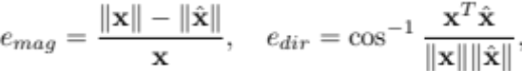
where 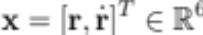 is the true state vector, and is the estimated state vector. In Figure 1c, it is illustrated that the direction estimation error is reduced immediately to the level of measurement noise, and the magnitude estimation error asymptotically converges. The true distance between the chief and the deputy and its estimated value are also shown in Figure 1d. Note that the direction of the state vector is observable from angles-only measurements, even for the linearized relative orbital dynamics. The magnitude of the state vector can be estimated only from the nonlinear relative orbital dynamics.
EXPECTED RESULTS and Significances
Most prior results on observability of relative orbits with angles-only measurements have assumed linear dynamics. Although it has been derived that linear relative orbital motion is unobservable from line-of-sight measurements if there is no external thrust, there has been no guarantee that relative orbital motion becomes observable for nonlinear two-body motion without thrust-induced maneuvering.
This paper provides systematic analyses to show that nonlinear relative orbital motion is indeed observable from angles-only measurements under certain conditions. In the final version of the paper, observability criteria with higher-order Lie derivatives will be investigated, and other numerical scenarios will be studied with an unscented Kalman filter.

REFERENCES
1 D. C. Woffinden and D. K. Geller, "Observability Criteria for Angles-Only Navigation." IEEE Transactions on Aerospace and Electronic Systems. Vol. 45, No. 3, 2009, pp. 1194–1208.
2 J. Tombasco, "Orbit Estimation of Geosynchronous Objects via Ground-Based and Space-Based Optical Tracking." Ph. D. Thesis, University of Colorado, 2011.
3 H. Patel, T. A. Lovell, S. Allgeier, R. Russell, and A. Sinclair, "Relative Navigation for Satellites in Close Proximity using Angles-Only Observations." AAS/AIAA Space Flight Mechanics Meeting, 2012, No. AAS 12-202.
4 R. Hermann, and A. J. Krener, "Nonlinear Controllability and Observability." IEEE Transactions on Automatic Control. Vol. 22, No. 5, 1977, pp. 728–740.

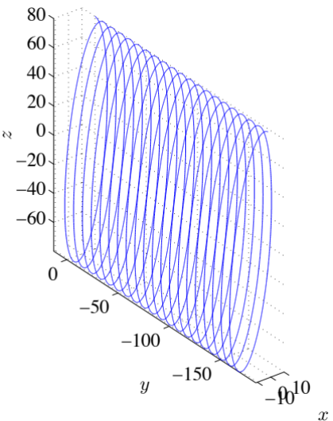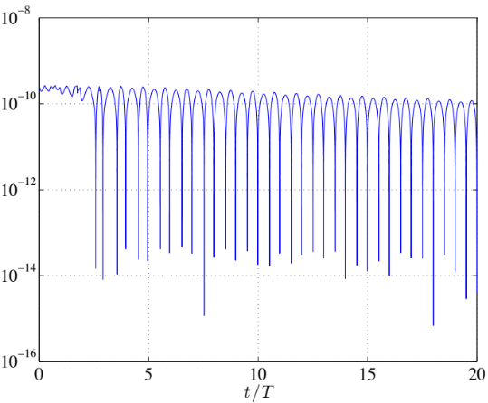
(a) Relative orbit trajectory in the LVLH frame (b) Min. singular value of the observability matrix

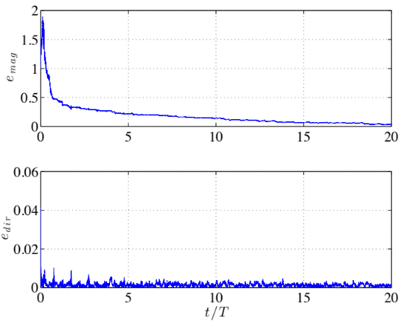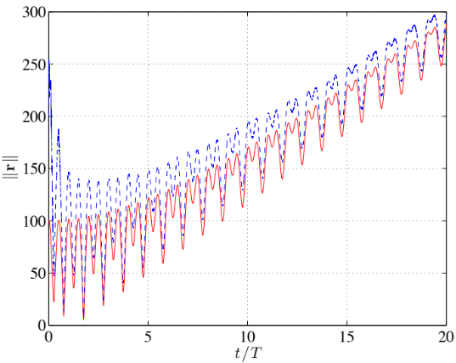
(c) Normalized estimation error in magnitudes and direction (d) True distance (red), estimated distance (blue) in km
Figure 1. Estimation of Relative Orbit

Research Aerospace Engineer, Air Force Research Laboratory, Space Vehicles Directorate, Kirtland AFB, NM.
Assistant Professor, Mechanical and Aerospace Engineering, George Washington University, 801 22nd St NW, Washington, DC 20052, Tel: 202-994-8710, Email: tylee@gwu.edu.

